Familiar and Unfamiliar Navigation Elements

Experiment – 04

1. **SIGN UP /HOME PAGE**

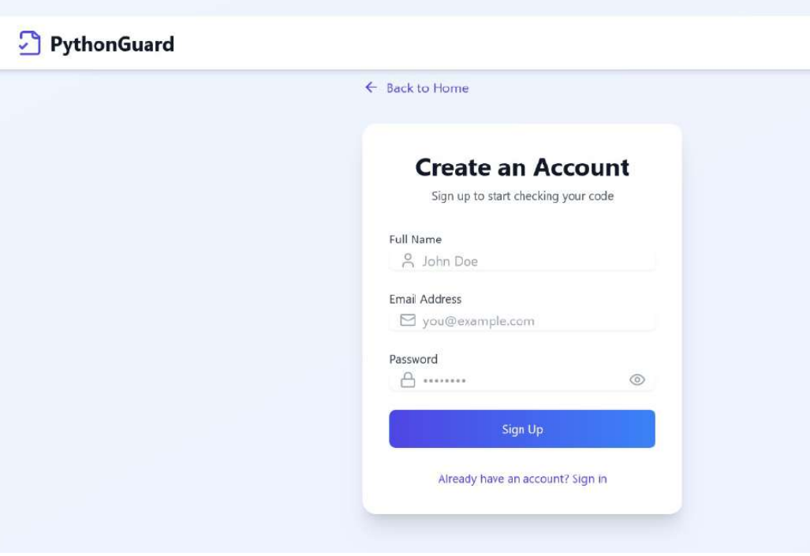

This is a user interface (UI) design for a sign-up page of an application called **PythonGuard**. The page has a clean and minimalistic look with a light purple and white color scheme. It includes:

* A **navigation link** at the top labeled "Back to Home" for returning to the main page.
* A **sign-up form** with fields for:
  + **Full Name** (e.g., John Doe)
  + **Email Address** (e.g., [you@example.com](mailto:you@example.com))
  + **Password** (with an eye icon for toggling visibility)
* A **"Sign Up" button** in a blue gradient color.
* A **link to log in** for existing users: "Already have an account? Sign in."

The UI is designed to be intuitive, ensuring users can quickly create an account and start using the platform, which appears to be related to code verification or analysis.

**2.Home Screen :**

This is the **PythonGuard** user interface for detecting plagiarism in Python code. The interface is clean, user-friendly, and designed to simplify the process of checking for similarities and potential plagiarism in Python scripts.

**Features of the Page:**

* **Header Section:**
  + The application name, **PythonGuard**, is displayed in the top-left corner.
  + Navigation options like **History** and **User Profile (John Doe)** are on the top-right.
* **Main Functionality:**
  + **Title:** *Python Code Plagiarism Detection* (emphasizing AI-powered analysis).
  + **Input Area:** Users can either:
    - **Paste Python code** directly into the text box.
    - **Upload a Python file** using the "Upload Python file" button.
  + **Check for Plagiarism Button:** A clear call-to-action in blue allows users to submit their code for analysis.
* **How It Works Section:**
  + **Input Code:** Users can paste or upload Python scripts.
  + **AI Analysis:** The system analyzes structural and syntactical similarities in code.
  + **Detailed Results:** Users receive a comprehensive plagiarism report.

This interface is well-structured to streamline the process of detecting plagiarism in Python code efficiently.

SARAVANAN B

230701293